Demonstrate virtualization by Installing Type-2 Hypervisor in your device, create and configure VM image with a Host Operating system (Either Windows/Linux).

Procedure

Step1: Creating a Duplicate Virtual machine.

Clicking NEXT Button by default.

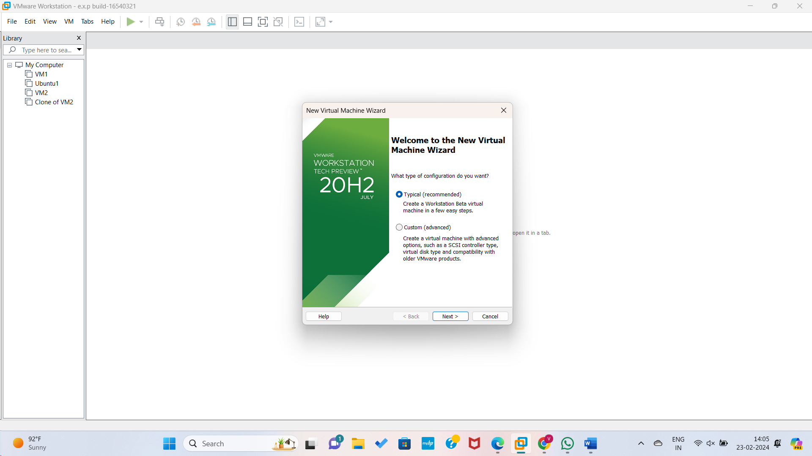

Step2: Choosing Guest Operating systems and clicking NEXT Button.

Step3: Choosing the operating system name and Clicking NEXT Button

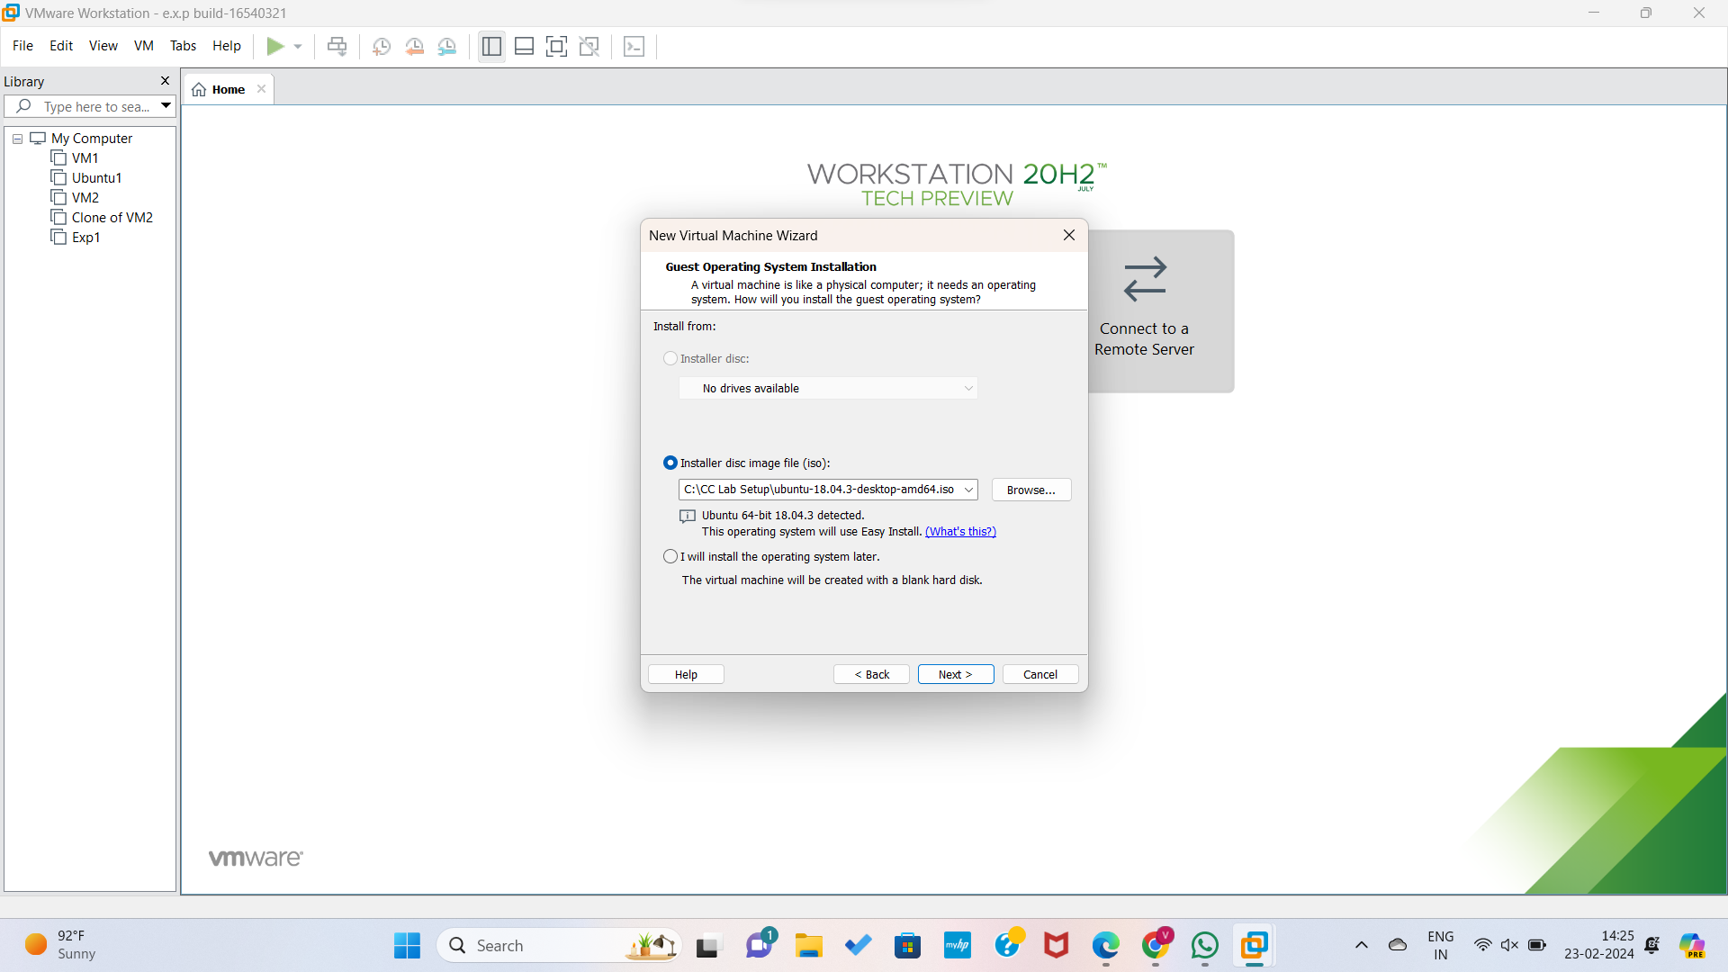

Step4: Giving details to create an operating system.

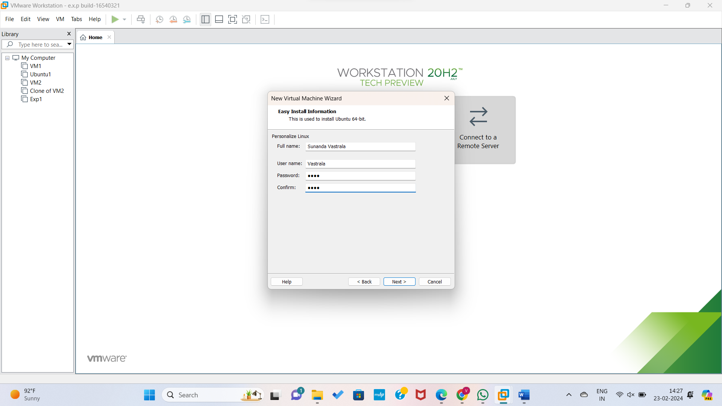

Step5: Giving virtual machine name.

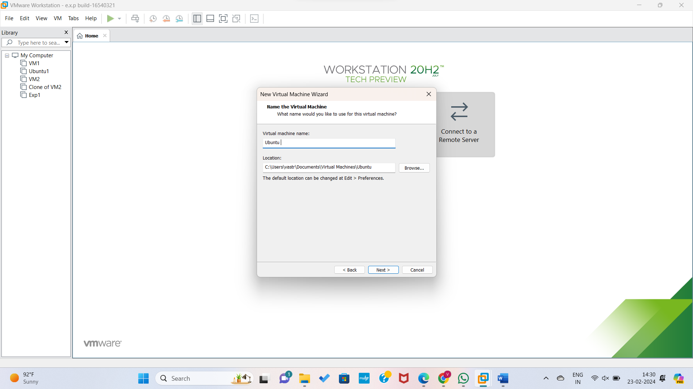

Step7: Choosing memory disk and and selecting a single virtual machine.

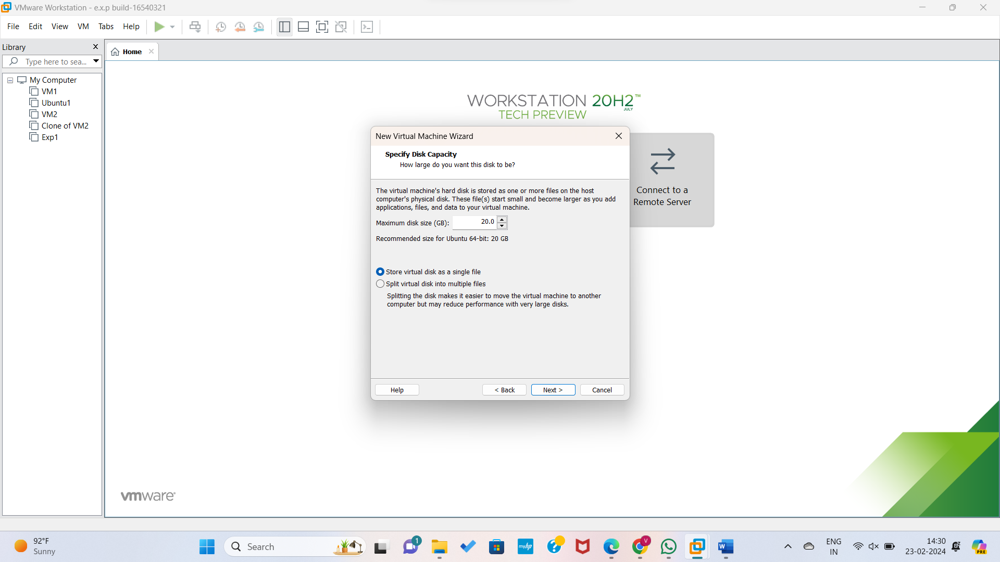

Step8: By finishing all the customs the Virtual machine is displayed.

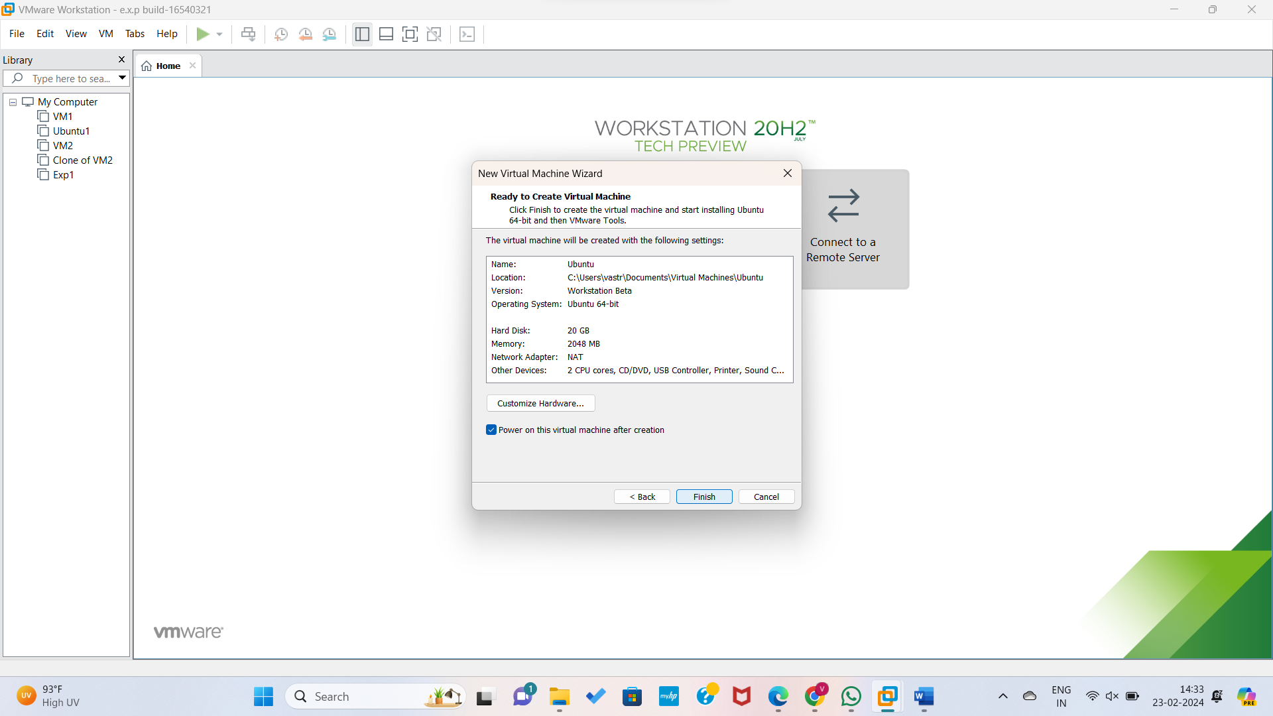

Step8: VMware Ubuntu software is downloading Virtually.

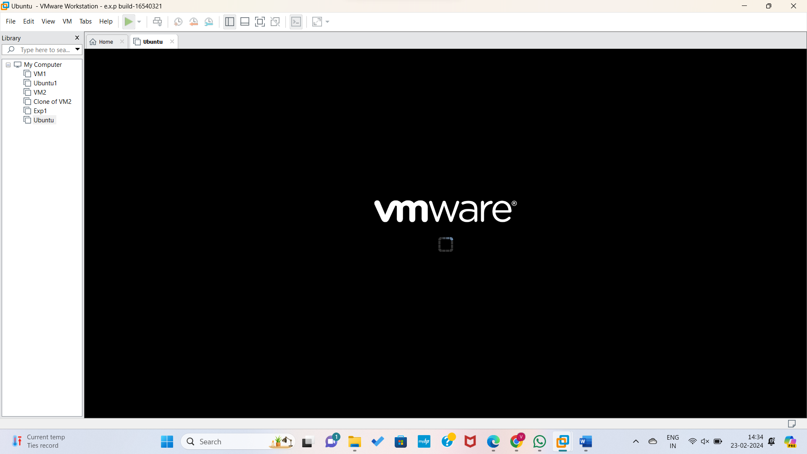

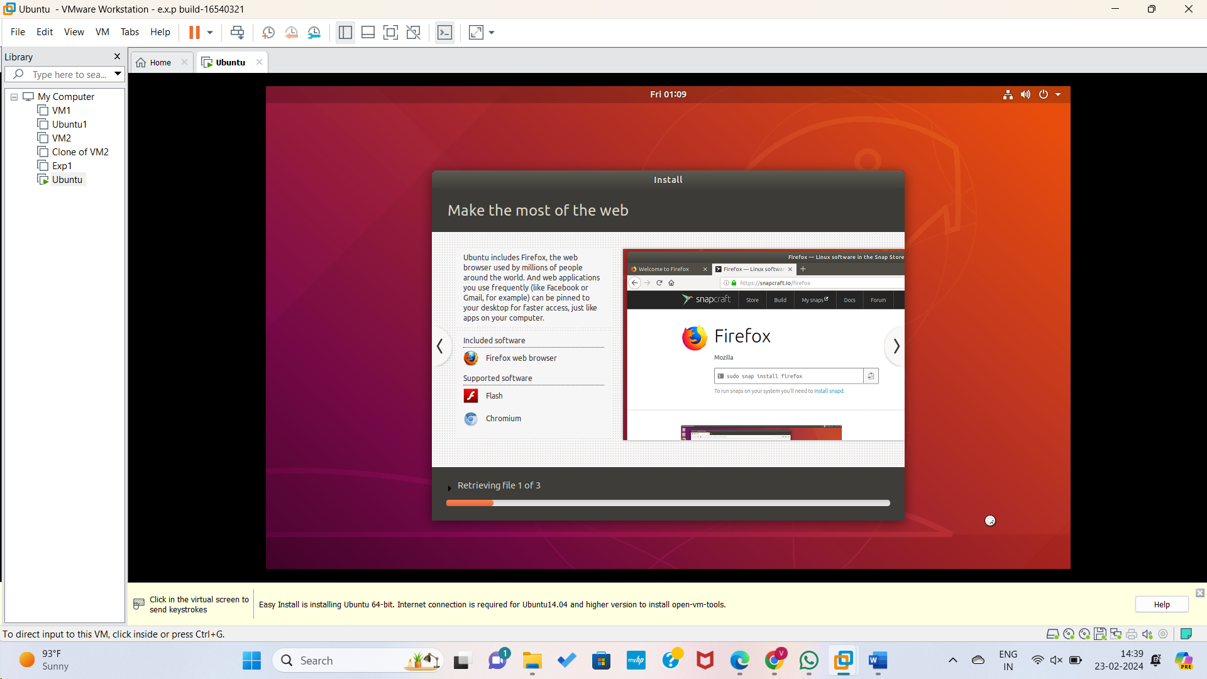

Step9: Ubuntu software virtually downloaded and Processing is going.

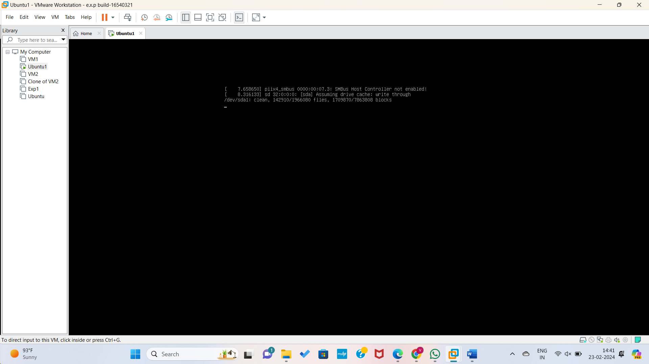

Hence UBUNTU Application Created Successfully through VMware..